# **Install OpenJDK For Windows**

**Steps To Install OpenJDK For Windows:**

1. Download latest OpenJDK from [https://openjdk.java.net/](https://openjdk.org/)



1. Extract All downloaded files.

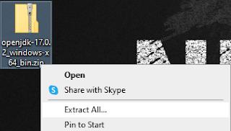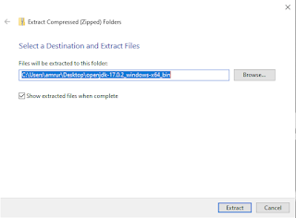

1. Go to C:\ and create a new folder. Named it Java.



1. Drag JDK inside the extracted folder into the Java folder.



1. Search for Edit the system environment variables and click it.

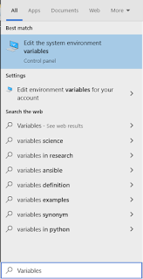

1. Click Environment Variables.

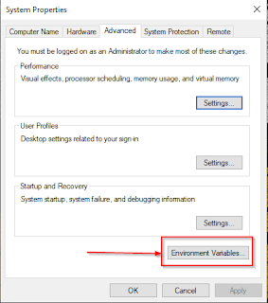

1. Click Path. After that, click Edit.

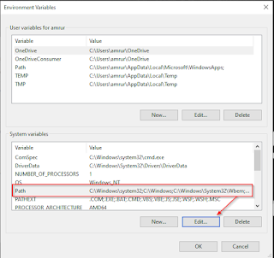

1. Click New.

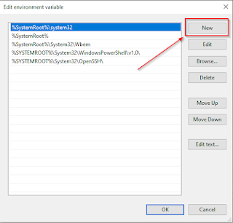

1. Put the path of bin folder from JDK inside the Java folder. After that, click OK.

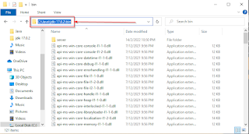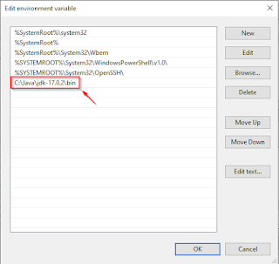

1. Click OK again. After that, click OK.

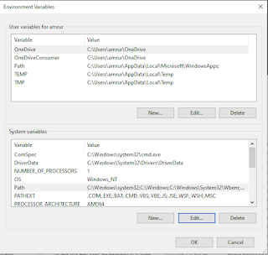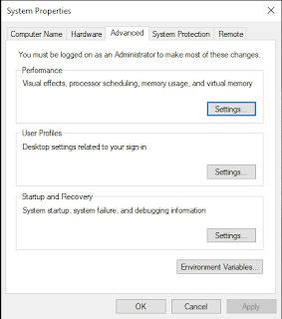

1. Check OpenJDK is successfully installed or not by using below command on CMD.

|  |
| --- |
| java -version |